13. Introduction to Firewalld

Tasks

1. Install firewalld on your Linux system, start the service, and verify its status using systemctl and firewall-cmd commands.

ANS:

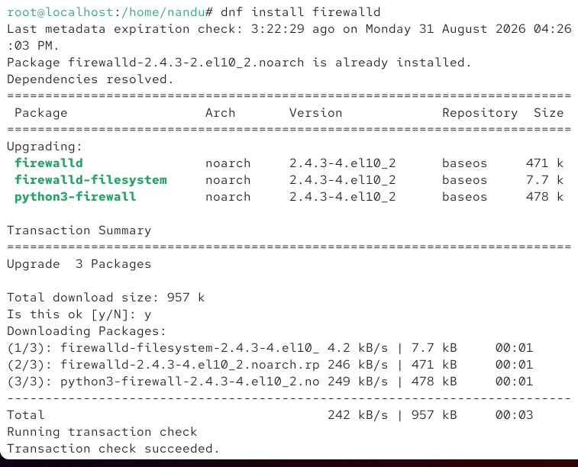

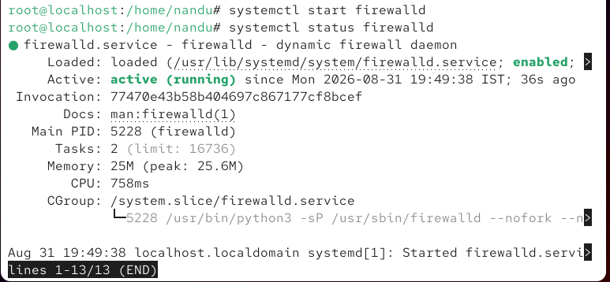

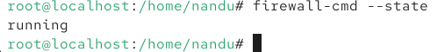

2. Add a new rule to firewalld to allow incoming HTTP (port 80) traffic, then use firewall-cmd to confirm the rule is active. Use the --permanent and --reload options to make changes persistent.

ANS:

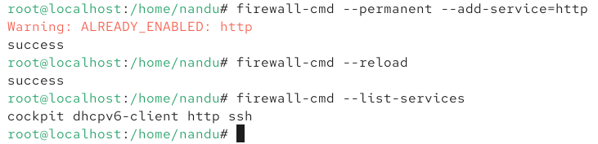

3. Temporarily block all incoming traffic on port 8080 using firewalld, then test by attempting to access a simple web server (e.g., Python's http.server) running on that port.

ANS:

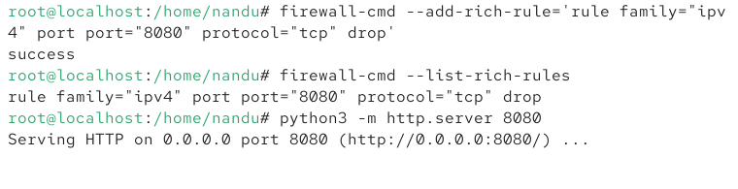

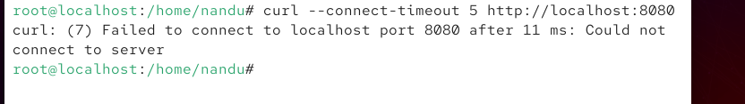

4. List all currently active firewalld zones and display the services and ports allowed in the public zone.

ANS:

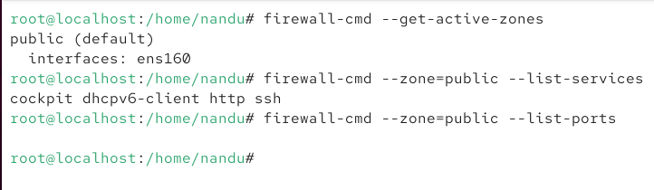

5. Remove a custom rule you added earlier (such as the HTTP port 80 rule) and verify that the change has taken effect using firewall-cmd.

ANS:

